LIMIT REFERENCE POINTS AND WILD SALMON POLICY RAPID STATUS SUMMARY:

2023 FRASER – LATE RUN SOCKEYE STOCK MANAGEMENT UNIT

Executive Summary
There are 6 CUs in the Fraser Late Run Sockey SMU and they are designed as 3 Red, 2 Amber and 1 Data Deficient recommended Red, placing this SMU below the LRP in terms of the 2022 WSP rapid statuses (Figures 1-12 & Table 3).
The Cultus-L CU was assessed as NA based on recent data deficiencies due to unassessed hatchery influences. Its recent average (233), including all hatchery-origin and hatchery influenced Sockeye, would be below 1,500 spawners and place it in the Red status. It’s prior integrated status from 2015 was Red. It is recommended to continue to treat this CU as Red.
The Harrison (D/S)-L CU was assessed as Red based on its recent generational average index (744) having a recent Percent-Change of -95%, which is below the lower threshold of -70%. It’s prior integrated status from 2015 was Amber-Green. The Rapid Status result was first Red in 2020.
The Harrison (U/S)-L CU was assessed as Red based on its recent generational average (9,378) being below its lower Relative-Abundance threshold (10,731). It’s prior integrated status from 2015 was also Red.
The Lillooet-Harrison-L CU was assessed as Amber based on its recent generational average (33,498) being between its lower and upper Relative-Abundance thresholds (14,178-84,623). It’s prior integrated status from 2015 was also Amber. There were three recent Rapid Statuses of Red from 2019-2021, indicating that this CU needs to be closely monitored.
The Seton-L CU was assessed as Red based on its recent generational average (1,368) being below 1,500 spawners. It’s prior integrated status from 2015 was also Red.
The Shuswap-L CU was assessed as Amber based on its recent generational average (7,739) being below the upper Absolute-Abundance threshold (10,000) but it’s dominant cycle return abundance (703,128) being above its lower Relative-Abundance threshold (310,783). It’s prior integrated status from 2015 was Amber-Green.

Context
A key recommendation from a CSAS peer review process on Pacific Salmon Limit Reference Points (LRPs) is ‘CU [conservation-unit] status-based LRPs’ be used to meet the Fish Stocks provisions of the Fisheries Act (DFO 2022; Holt et al. 2023a, 2023b), which was supported nationally (DFO 2023). LRP's are assessed for Stock Management Units (SMUs), which can include one or more conservation units (CUs) (i.e., CUs are nested within SMUs). Using this approach, serious harm to a SMU is identified when any component CU zone drops into the Wild Salmon Policy (WSP) Red zone. Under this definition, the CU status-LRP is ‘100% of CUs with statuses above Red status’. The implications are that if a single CU is the Red status zone, the SMU is assessed as being below its LRP, which in turn triggers a DFO rebuilding plan for the SMU.

Forewords
Please fill in with perspectives or values that are not captured through the Rapid Status Assessment algorithm. Include whom the forewords should be attributed to (may be a group or individuals).

Data
The Fraser – Late Run Sockeye SMU is comprised of five non-cyclic CUs (Cultus-L ; Harrison (D/S)-L; Harrison (U/S)-L; Lillooet-Harrison-L; and Seton-L) with a combined 7 streams that were used in the assessment and one cyclic CU (Shuswap-L) with 28 streams (or shorelines) used in its assessment (Table 1). The data used in this assessment were described in detail in Grant et al. (2011), Grant & Pestal (2012), and Grant et al. (2020). The last integrated status assessments for these CUs occurred for return year 2017 (Grant et al. 2020). Some of the data was also recently used in the Fraser Sockeye Recovery Potential Assessments (Huang et al. 2021; Doutaz et al. 2023).
The primary forms of spawner enumeration surveys vary across the CUs in this SMU. Cultus-L almost explicitly is enumerated at a fixed census site. Harrison (U/S)-L primarily uses mark-recapture (historical), fixed-site census (e.g. trap and fence), and visual survey expansions (peak live + cumulative dead). Harrison (D/S)-L and Seton-L primarily use visual survey expansions. Lillooet-Harrison-L has transitioned through primarily mark-recapture, fixed site census, and most recently SONAR. Shuswap-L is primarily estimated through mark-recapture and supported with visual survey expansions and most recently with SONAR. When spawner abundance is forecasted to be greater than 75,000, then one of the higher precision methods (mark-recapture, fixed-cite census, SONAR) are implemented. The timeseries for these CUs start as early as 1950, and for this assessment, end with data from 2023.
Key steps in the data processing of this data set includes stream selection, gap infilling, and assessing data quality, which are described in detail in Grant et al. (2011). Streams were selected for inclusion in the assessment if they were surveyed for >70% of the historical time series. Missing stream-years for CUs with multiple sites were gap filled using a cyclic-specific (or non-specific if non cyclical) mean proportion approach, which leverages spatially proximate and correlated system’s abundance. Missing stream-years for CUs with single sites used cycle (or generational for non-cyclic) averages from adjacent generations. Data quality is assessed based on the number and completeness of surveys, coverage of the spawning period, visibility and reliability records, and methodology.
The average spawner data quality of Lillooet-Harrison-L, Shuswap-L CU is considered “very good” and Harrison (U/S)-L, and Seton-L are considered “good” and representative of the total CU abundance (Grant et al. 2020). The CU data for the former mentioned CUs are treated as absolute abundance that can be used in the absolute abundance and relative abundance-based benchmark metrics. The data quality of Harrison (D/S)-L was considered “good”, but only for a single stream that is known to be an underestimate of the total CU abundance. The Harrison (D/S)-L timeseries is thus treated as relative abundance only and is not used in the absolute abundance and relative abundance-based benchmark metrics.
The Cultus-L spawner data is “excellent” as all fish are enumerated through a fixed site census (fence and trap) but due to it’s high level of hatchery influence and low proportion of natural influence (PNI) the recent spawner data does not meet the criteria of “Wild” under the WSP. Therefore, no Rapid Status is assigned to Cultus-L, but it is accepted that the natural population is so depressed that it’s status under the WSP is considered to be Red.
Relative Abundance Benchmarks:
Relative abundance-based benchmarks for all of the non-cyclic CUs, with the exception of Harrison (D/S)-L, in this SMU were developed using Ricker Stock-Recruit models (Grant et al. 2020). Benchmarks for each CU were last updated using brood year data from 1966-2010, 1965-2010, and 1950-2010 for Harrison (U/S)-L, Seton-L, and Lillooet-Harrison-L, respectively (Grant et al. 2020). The 50th percentile and 80 percent interval of Ricker-based benchmarks are presented for each CU (Table 2). Cultus-L benchmarks are also presented for consideration and context.
Relative abundance-based benchmarks for Shuswap-L CU were developed using a Larkin Stock-Recruit model due to it’s cyclic nature (Grant et al. 2020). Benchmarks for each cycle line (one dominant and three weak cycles) were last updated using brood years 1950-2010 (Grant et al. 2020). The 50th percentile and 80 percent interval of Larkin-based benchmarks are presented for each cycle line (Table 2). In mimicking the integrated status approach and results, only the dominant cycle brood line is assessed against it’s relative abundance-based benchmark; which then stands as that metric’s result for the subsequent three cycle line’s years. i.e. The most recent dominant cycle line year for Shuswap-L is 2022. The comparison of the 2022 effective total spawner abundance is compared against it’s dominant cycle specific relative abundance benchmark. The result of this comparison is then used for return years 2022-2025 until the next dominant cycle return in 2026.
Table 1. Conservation Units (CUs) included in this Stock Management Unit (SMU) and lists of the streams/populations within each CU used in the Rapid Status Assessment. Streams have their NuSEDS population identifications in brackets.
CU No# | CU Name | Streams (Population ID) | Timeseries
SEL-03-02 | Cultus-L | Cultus Lake (45093)
SEL-03-03 | Harrison (D/S)-L | Big Silver Creek (46072) | 1950-2023
SEL-03-04 | Harrison (U/S)-L | East Creek (46055)  Weaver Channel (45087)  Weaver Creek (46044) | 1966-2023
SEL-04-01 | Lillooet-Harrison-L | Birkenhead River (46098) | 1950-2023
SEL-06-11 | Seton-L | Portage Creek (47181) | 1965-2023
SEL-09-03 | Shuswap-L | Adams River - shore (3393)  Adams River, lower (46239)  Adams River, upper (46249)  Anstey River (46349)  Anstey River - shore (3439)  Cruikshank Pt. West - shore (3394)  Eagle River (46359)  Hlina Creek - shore (3395)  Lee Creek - shore (3396)  Little River (46228)  Lower Shuswap River (46429)  Middle Shuswap River (46440)  Momich River (46269)  Onyx Creek - shore (3399)  Ross Creek - shore (3400)  Scotch Creek (46289)  Scotch Creek - shore (3401)  Shuswap L. - Main Arm north side (3397)  Shuswap L. - Main Arm south side (3398)  Shuswap L. - Salmon Arm east side (3403)  Shuswap L. - Salmon Arm north side (3404)  Shuswap L. - Salmon Arm south side (3405)  Shuswap Lake (45764)  Shuswap Lake - Anstey Arm (7421)  Shuswap Lake - Main Arm (7424)  Shuswap Lake - Salmon Arm (7423)  Shuswap Lake - Seymour Arm (7422)  South Thompson River (46218) | 1950-2023f

Table 2. Relative abundance-based benchmarks and credible intervals by Conservation Unit (CU) and Cycle Line. Values were estimated in Grant et al. (2020). *Denotes the Dominant Cycle Line, which is used in the Rapid Status Assessment. Upper Benchmarks are multiplied by 1.1 in the algorithm.
CU Name | Cycle Line Recent Year | Benchmark | p50 | Credible Interval (p10-p90)
Cultus-L | - | 80% S_{MSY} | 32,556 | 22,855 – 47,309
Cultus-L | - | S_{gen} | 15,454 | 10,391 – 23,107
Harrison (D/S)-L | - | No Upper | - | -
Harrison (D/S)-L | - | No Lower | - | -
Harrison (U/S)-L | - | 80% S_{MSY} | 84,597 | 53,638 – 198,497
Harrison (U/S)-L | - | S_{gen} | 10,731 | 5,475 – 32,353
Lillooet-Harrison-L | - | 80% S_{MSY} | 76,930 | 63,207 – 99,625
Lillooet-Harrison-L | - | S_{gen} | 14,178 | 9,765 – 21,783
Seton-L | - | 80% S_{MSY} | 13,453 | 9,108 – 25,948
Seton-L | - | S_{gen} | 2,193 | 1,224 – 5,294
Shuswap-L | 2022* | 80% S_{MSY} | 1,794,869 | 1,283,649 – 2,986,004
Shuswap-L | 2022* | S_{gen} | 310,783 | 177,273 – 620,666

WSP Rapid Status Summary
Stock Management Unit (SMU) Limit Reference Point (LRP) status and narrative based on expert consensus
There are 6 CUs in the Fraser Late Run Sockey SMU and they are designed as 3 Red, 2 Amber and 1 Data Deficient recommended Red, placing this SMU below the LRP in terms of WSP rapid status (Figures 1-12 & Table 3).
Summarize any additional information and comments from the expert review.
The background descriptions of the CUs from the 2015 (Grant et al. 2020) assessments remain appropriate and have been copied for the beginning of each CU’s narrative.

Cultus-L
This CU was listed as ‘endangered’ by COSEWIC in 2003 (COSEWIC 2003) and was still ‘endangered’ in the more recent 2017 assessment (COSEWIC 2017). A Cultus Conservation Team has coordinated multiple initiatives focused on the recovery of this CU since this designation. For conservation purposes, this CU has been hatchery enhanced since 2000; all hatchery fish are marked with an adipose-fin-clip. Adult Cultus Sockeye are enumerated at the counting fence located in Sweltzer Creek, along with unmarked fish.
For this status assessment, hatchery marked fish need to be removed from the escapement time series and generational hatchery influences are still being assessed. Adipose-clip failure occurs at a low rate in marked fish, which may result in some fish identified as ‘wild’ actually being hatchery fish. In addition, offspring from naturally spawning hatchery-origin parents remain in the escapement time series for the status assessment, since these fish have no external marks for identification at the enumeration fence. These offspring from hatchery-origin parents are not considered ‘wild’, as defined by the WSP. Note that while both a captive brood stock (CBS) and hatchery program were operated for a number of years starting in the 2000 brood year, the CBS program was terminated recently (see Grant et al. 2011). This has considerably reduced the number of smolts produced by this system.
Input data for the Rapid Scanner Assessment Method is still being reviewed and treatments considered due to the uncertainties introduced by the high rates of hatchery influence; however, an interim status is recommended. The Rapid Status is “data deficient” but we recommend that the Status be Red since the geometric generational average spawner abundance has been below 1,500, inclusive of hatchery-origin spawners, since 2018. The 2022 generational geometric average spawner abundance was 233. Therefore, it is known that the wild contribution would be less than these values that include hatchery-origin Sockeye. So if this data was run through the Rapid Status Algorithm, then it would achieve the Red with High Confidence status solely based on Node 1, arriving at Node 3 (Figure 1).

Harrison (D/S)-L
Harrison (D/S)-L is comprised of several separate stream populations that migrate downstream to rear in Harrison Lake during their freshwater fry stage; only a single population (Big Silver Creek) is used for status assessments as it has been consistently assessed and has a relatively long time series of escapement data (Grant et al. 2011). Since only one population is consistently assessed escapement estimates to the CU are biased low.
Big Silver Creek spawner abundance was relatively low and constant from the 1950s until the 1990s. Abundance increased steeply in the 2000s to a peak in 2002. There was a period of decline but still moderately high spawner abundances up until 2018, after which, abundance steeply declined to levels comparable to the pre-1990 period.
The prior 2015 Integrated Status was Amber-Green. There was a reduction in status in the 2022 Rapid Status, which is Red with Medium Confidence

Harrison (U/S)-L
A spawning channel adjacent to Weaver Creek started operations in 1965 to re-build production of the Harrison (U/S)-L CU, and subsequently allow for increased harvest opportunities on the Late Run CUs. The channel was also constructed to protect this CU from periodic flooding events; sockeye are preferentially diverted by channel operators into the channel rather than the creek in this system. Channel freshwater production is higher than the adjacent Weaver Creek (Grant et al. 2011). A massive landslide (Meager Creek) occurred upstream of Harrison Lake in 2010. This landslide created a large sediment plume at the north end of Lillooet Lake. This sediment plume moved south into Harrison Lake over the next year, where juveniles from this CU rear. Both Lillooet-Harrison-L and Harrison (U/S)-L CUs exhibited poor survival in the years following this landslide.
Spawner abundance in Harrison (U/S)-L has been quite variable through time. There was a general increase after 1965 to a massive peak spawner abundance in 1982. Since the mid-1980s, the population abundance has increased and decreased multiple times, but there was a general decreasing trend until the most recent spawner abundances. However, the generational geometric mean abundance remains below the lower relative abundance-based benchmark.
The prior 2015 Integrated Status was Red. There was a no change in status in the 2022 Rapid Status, which is Red with High Confidence

Lillooet-Harrison-L
Only the Birkenhead River is included in the abundance time series for Lillooet-Harrison-L, since it has been consistently assessed and has a relatively long and complete time series (Grant et al. 2011). A massive landslide (Meager Creek) occurred on this system in 2010. This landslide created a large sediment plume at the north end of Lillooet Lake, where fry from this CU first enter the lake from the spawning habitat in Birkenhead River. As noted above, both Lillooet-Harrison-L and Harrison (U/S)-L CUs exhibited poor survival in the years following this landslide.
The spawner abundance of Birkenhead River generally increased since the 1950s to the highest abundances in the timeseries recorded in 1986. There were periodic high abundances through to 2011 followed by a sharp decline until 2021 and 2022, which recently brought the generational geometric average above the lower benchmark in return-year 2022.
The prior 2015 Integrated Status was Amber. There was a no change in status in the 2022 Rapid Status, which is Amber with High Confidence

Seton-L
The original Seton-L CU was extirpated by poor hatchery husbandry techniques and the Hells Gate landslide. Subsequently hatchery transplants were used initially to re-build this population (hatchery supplementation does not occur currently). This population re-established and is labelled de novo due to its hatchery origins. These fish must migrate through a hydroelectric facility, which can represent challenges to migration (detailed in Grant et al. 2011).
The spawner abundance generally increased from the 1960s to mid-1990s and has since declined, on average, with a few notably high spawner abundances in 2010 and 2018 (highest in the time-series). The four-year-geometric average has remained below 1,500 spawners since 2015, with the exception of 2021.
The prior 2015 Integrated Status was Red. There was a no change in status in the 2022 Rapid Status, which is Red with High Confidence

Shuswap – L
Shuswap-L comprises a large proportion of the total Fraser Sockeye return abundance during its dominant cycle years; in contrast the subdominant and weak cycles of this CU have relatively small abundances (see Grant et al. 2011 for further details).
The dominant cycle spawner abundance generally increased from the 1950s with a peak in abundance between 1980-1990, followed by a drop in the 1990s. The two largest spawner abundances in the timeseries occurred in 2002 and 2010, which have subsequently been followed by a decline in abundance. Since 2003, the cycle line that was originally identified as the sub-dominant line (2023) has had very low abundances, but there are concerns with regards to the lower data quality methods used to enumerate non-dominant cycle lines.
The prior 2015 Integrated Status was Amber-Green. There was a reduction in status in the 2022 Rapid Status, which is Amber with High Confidence
Reference the list of meetings and contributors can be found in Appendix 2
Future work: Please fill in with future works that were suggested by subject matter experts with regards to assessing population status.
Table 3. Wild Salmon Policy (WSP) Rapid Statuses for 2022. For background, refer to Appendix A.
CU # | CU Name | WSP Rapid Status (2022) | WSP Rapid Status Node and Pathway
SEL-03-02 | Cultus-L | NA,  NA | The input data to represent Cultus-L is not ready as of this meeting. However, the total (hatchery-origin inclusive) 2023 average spawner abundance was 163, which is below the lower Absolute-Abundance Threshold of 1,500. The geometric generational average spawner abundance has been below 1,500, since 2018, which would result in a consistent Red with High Confidence status. It is known that the wild contribution would be less than these values that include hatchery-origin Sockeye. So if this data was run through the Rapid Status Algorithm, then it would achieve the Red with High Confidence status solely based on Node 1, arriving at Node 3 (Figure 1).
SEL-03-03 | Harrison (D/S)-L | RED,  MEDIUM | The recent year’s status (2023) is designated Red with Medium confidence based on the algorithm. The data could not be assessed as Absolute Abundance. The recent Percent-Change is -95%, which is less than the Percent Change Threshold of -70% (Node 33, Figures 3-4, Table 5). This Red status has been variable throughout the status time series with Red only in years 2014-2015 and 2020-2022 (Figure 3). The 2015 WSP rapid status of Red does not match the WSP integrated status from 2015 of Amber-Green (DFO 2020). Since this CU does not have Absolute Abundance data, there is less certainty in the status; however, The geometric average generational index of abundance is 744 and has been below 1,500 since 2019. The Long-Term Trend Metric has consistently declined since a high in 2006 and the Percent Change Metric has recently dropped below half in the last three generations.
SEL-03-04 | Harrison (U/S)-L | RED,  HIGH | The recent year’s status (2023) is designated Red with High confidence based on the algorithm. The data could be assessed as Absolute Abundance. The recent generational average is 9,378 spawners, which is below the lower Relative-Abundance Threshold (Node 23, Figures 5-6, Table 6). This Red status has been consistent since 2015, while prior it was Amber (Figure 5). The 2015 WSP rapid status of Red matches the WSP integrated status from 2015 (DFO 2020). Although not used to assess status for this CU, the Long-Term Trend and Percent Change Metrics have both been in their Red zones since 2010 and 2009, respectively. The spawner abundances in 2021-2022 have been better, but 2019-2020 were record or near record low spawner abundances.
SEL-04-01 | Lillooet-Harrison-L | AMBER,  HIGH | The recent year’s status (2023) is designated Amber with High confidence based on the algorithm. The data could be assessed as Absolute Abundance. The recent generational average is 33,498 spawners, which is below the upper Relative-Abundance Threshold but above the lower Threshold (Node 37, Figures 7-8 Table 7). This Amber status has been variable throughout the status time series from 2007 to 2018 and then recently in 2022 after a series of Red statuses in 2019-2021 (Figure 7). The 2015 WSP rapid status of Amber matches the WSP integrated status from 2015 (DFO 2020). The Long-Term Trend and Percent Change Metrics both have indicated general declines in abundance, entering their Red zones in 2019 and 2012, respectively. The recent spawner abundances from 2021-2023 are relatively high and are the reason that the average has been pulled back above the lower Relative-Abundance Threshold. This CU could be flagged for nearing the Red Status again; however, the 2023 spawner abundance estimate (~75,900) was also nearing the upper Relative-Abundance Threshold.
SEL-06-11 | Seton-L | RED,  HIGH | The recent year’s status (2023) is designated Red with High confidence based on the algorithm. The data could be assessed as Absolute Abundance. The recent generational average is 1,368 spawners, which is lower than the lower Absolute-Abundance Threshold of 1,500 (Node 3, Figures 9-10, Table 8). This Red status has been consistent throughout the status time series since 2009 (Figure 9). The 2015 WSP rapid status of Red matches the WSP integrated status from 2015 (DFO 2020). Although not used to assess status for this CU, the Long-Term Trend and Percent Change Metrics have both been in their Red zones since 2011 and 2001, respectively.
SEL-09-03 | Shuswap-L | AMBER,  HIGH | The recent year’s status (2023) is designated Amber with High confidence based on the algorithm. The data could be assessed as Absolute Abundance. The recent generational average is 7,739 spawners, which is below the upper Absolute-Abundance Threshold. The recent dominant year estimate is 703,128, which is above the lower Relative-Abundance Threshold (Node 23, Figures 11-12, Table 9). This Amber status has been consistent throughout the status time series since 2017, while previously it was Green (Figure X). The 2015 WSP rapid status of Green is similar to the WSP integrated status from 2015 of Amber-Green (DFO 2020). Although not used to assess status for this CU, the Long-Term Trend and Percent Change Metrics have both been in their Red zones since 2015 and 2012, respectively.

SEL-03-02 Cultus-L
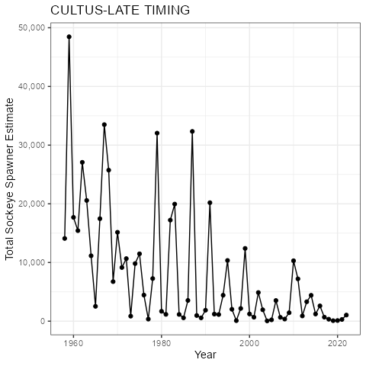
Figure 1: Abundance of Cultus-L (SEL-03-02) Sockeye. Official Wild Salmon Policy (WSP) figures were not made for Cultus due to the uncertain effect of hatchery-origin spawners and genetics, which may exclude a portion of the returns from the definition of wild under the WSP.
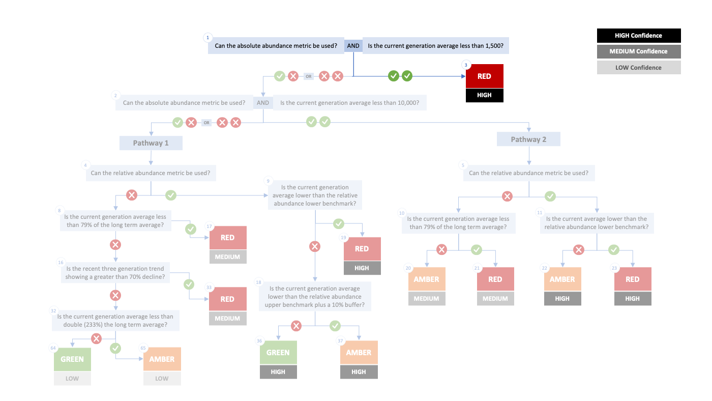Figure 2. Algorithm pathway suggested for the Cultus-L (SEL-03-02) in 2023. The recent generational average would fall below the absolute abundance lower (1,500) threshold (node 1). Status for this CU is therefore suggested as Red with High confidence at Node 3.
Table 4: Decision tree path given data and metric values for the Cultus-L (SEL-03-02) in 2023; this aligns with Figure 2 above. For each node, the algorithm decision is made by comparing the CUs current metric value to the metric threshold and answering Yes or No, running through sequential nodes and decisions until the final WSP rapid status for that CU and year is reached. *This abundance includes hatchery-origin Sockeye and is not the official value for WSP assessment.
Node | Metric | Metric Threshold | CU’s Current Value | Decision
1 | Absolute Abundance | <1,500 | 233* | YES, YES
3 | FINAL STATUS NODE |  |  | RED, HIGH

SEL-03-03 Harrison (D/S)-L
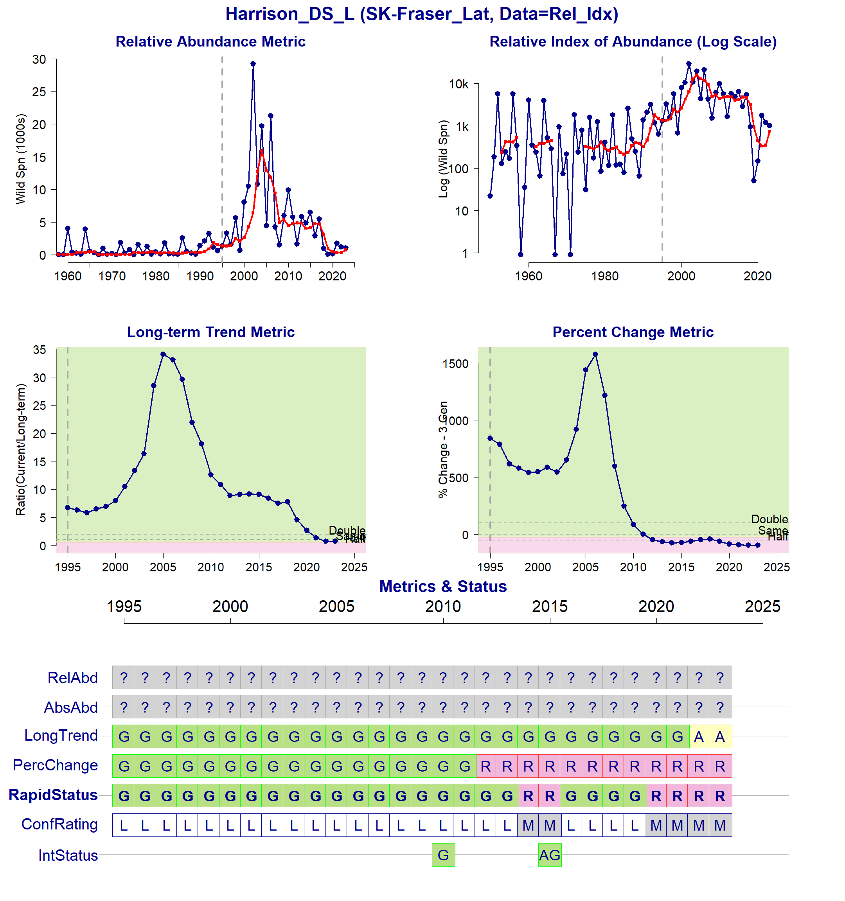Figure 3: Metrics and Status for Harrison (D/S)-L (SEL-03-03). Panels on top show the four standard WSP metrics, calculated based on the available time series of spawner abundances. Bottom panel summarizes the status for each individual metric and shows the resulting WSP rapid status for the CU with a confidence rating. This CUs abundance is not considered Absolute; therefore, the Relative-Abundance and Absolute-Abundance Metrics could not be assessed. If integrated WSP status assessments have been completed for this CU, they are shown on the last row (IntStatus). Note that metric benchmarks may differ from algorithm thresholds, since thresholds approximate the status determination process from past WSP integrated status assessments (see Figure 4).
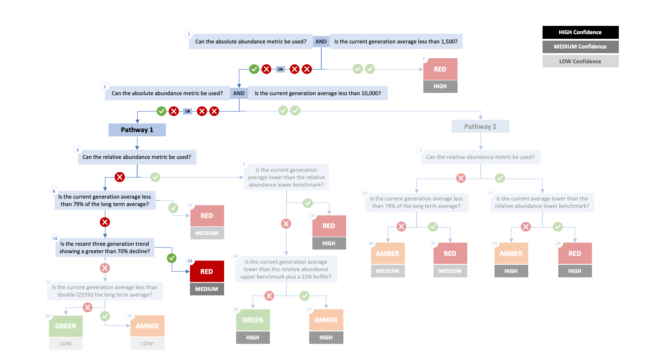Figure 4. Algorithm pathway taken to assess status for the Harrison (D/S)-L (SEL-03-03) in 2023. The spawner abundance is not considered Absolute (node 1-2) and there are no relative abundance thresholds, the long term trend and percent change metrics are used (nodes 4, 8, and 16). Status for this CU is therefore designated as Red with Medium confidence at Node 33.
Table 5: Decision tree path given data and metric values for the Harrison (D/S)-L (SEL-03-03) in 2023; this aligns with Figure 4 above. For each node, the algorithm decision is made by comparing the CUs current metric value to the metric threshold and answering Yes or No, running through sequential nodes and decisions until the final WSP rapid status for that CU and year is reached.
Node | Metric | Metric Threshold | CU’s Current Value | Decision
1 | Absolute Abundance | <1,500 | - | NO, NA
2 | Absolute Abundance | <10,000 | - | NO, NA
4 | Relative Abundance | Available? | - | NO
8 | Long-Term Trend | <79% | 82% | NO
16 | Percent-Change | <-70% | -95% | YES
33 | FINAL STATUS NODE | - | - | RED, MEDIUM

SEL-03-04 Harrison (U/S)-L
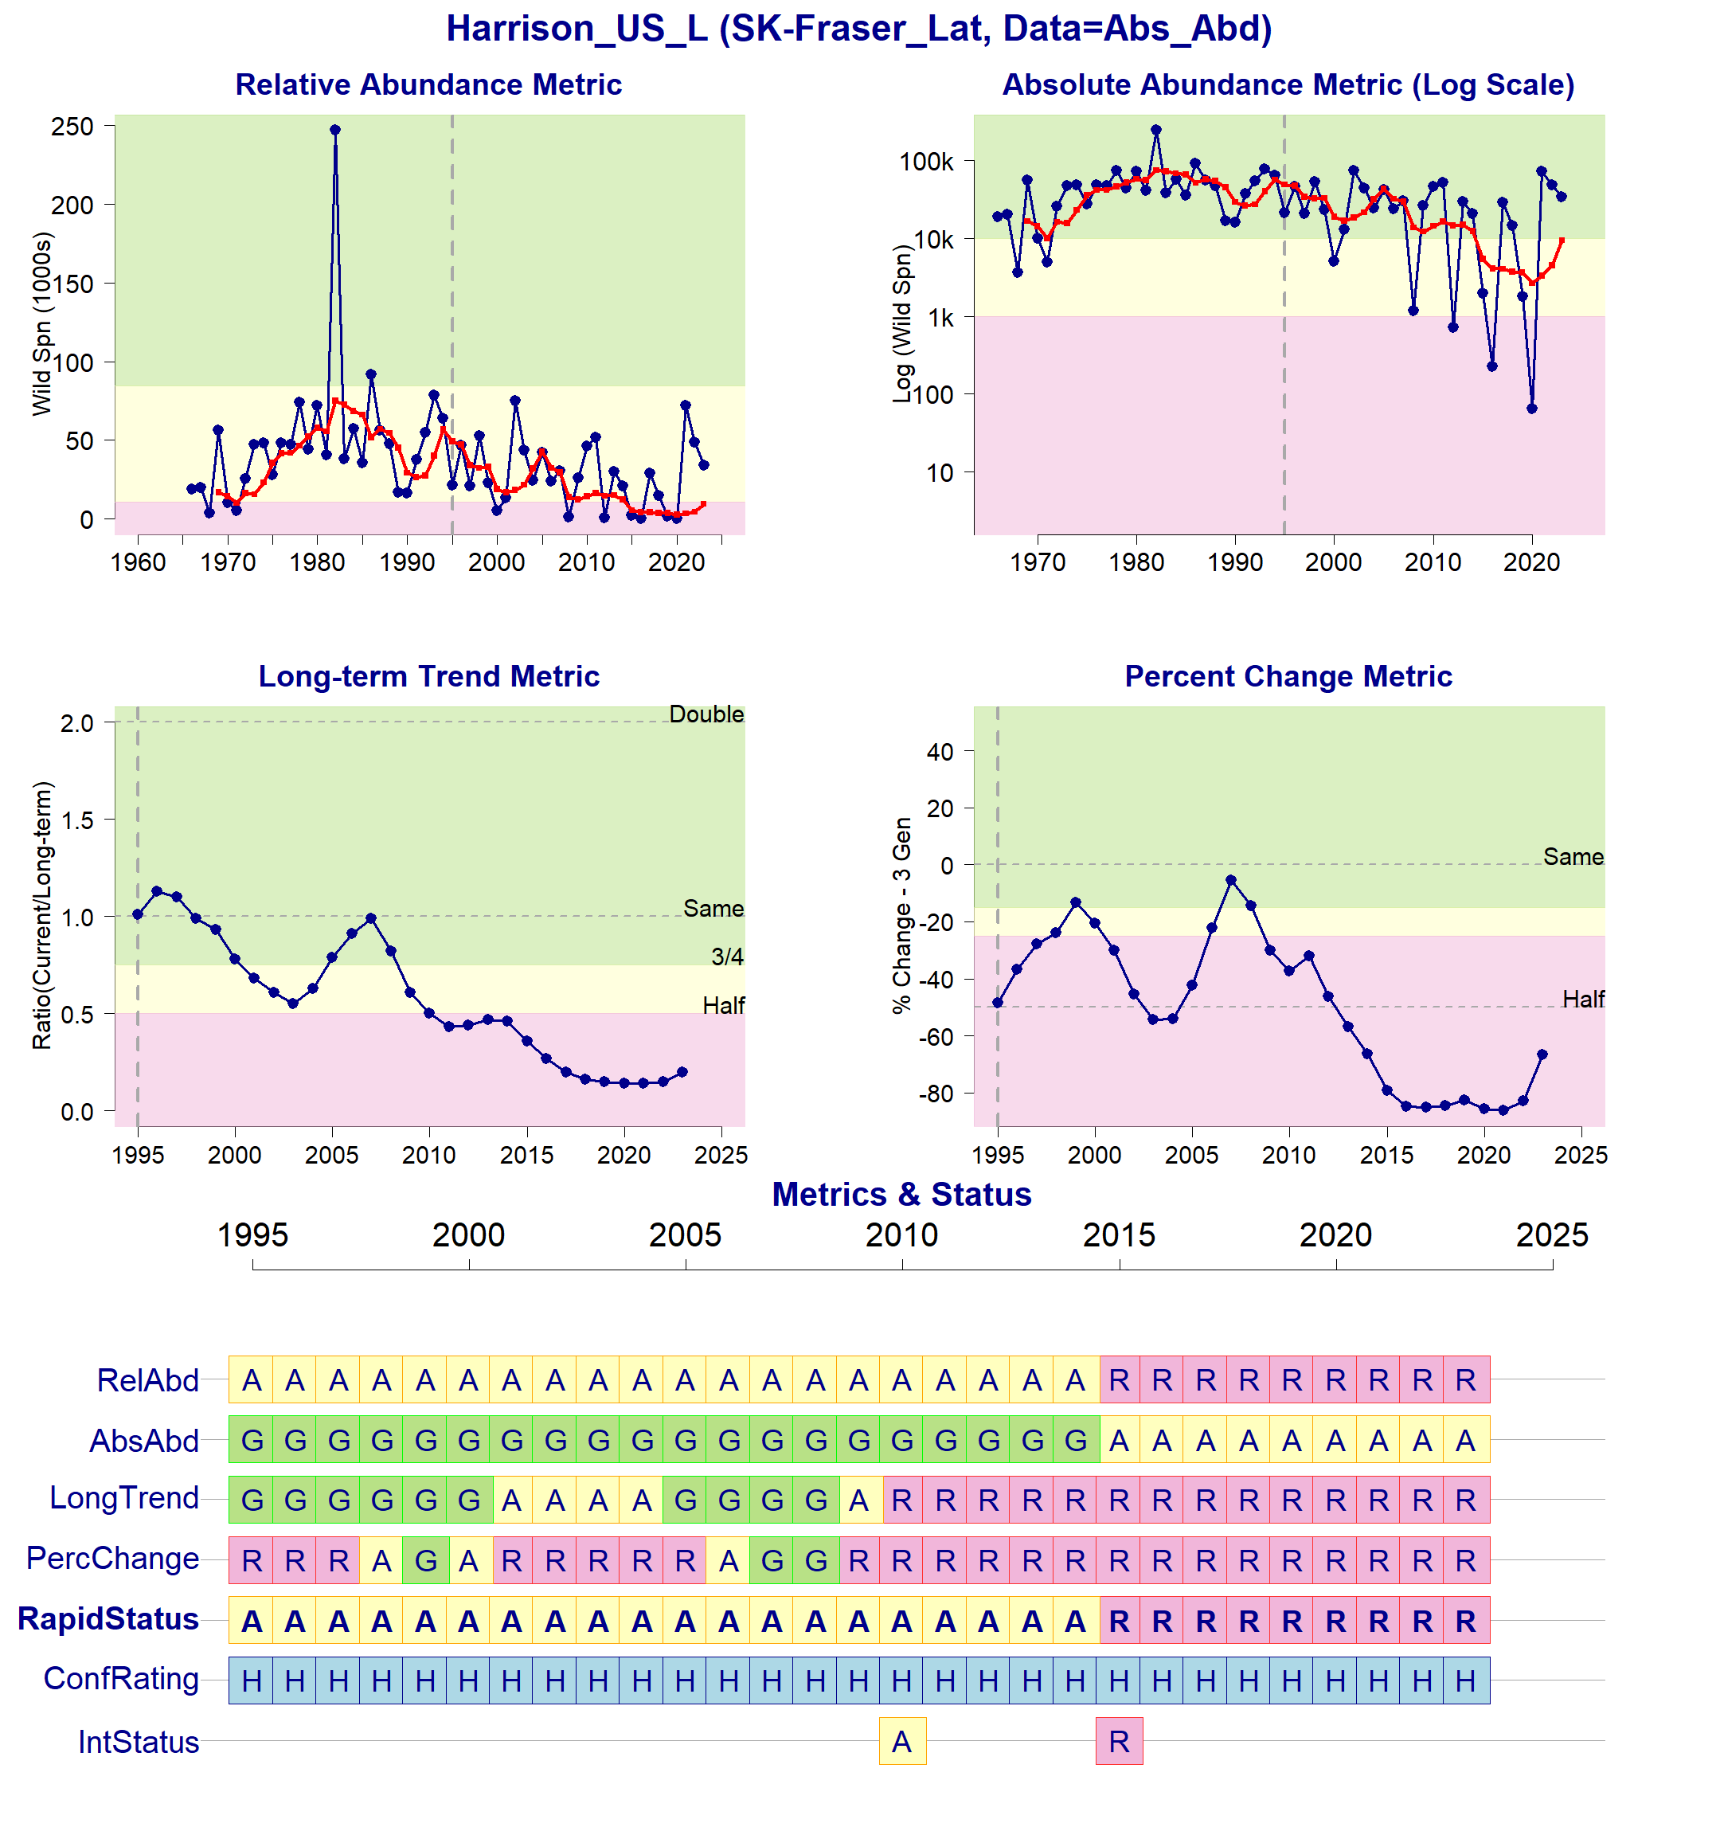Figure 5: Metrics and Status for Harrison (U/S)-L (SEL-03-04). Panels on top show the four standard WSP metrics, calculated based on the available time series of spawner abundances. Bottom panel summarizes the status for each individual metric and shows the resulting WSP rapid status for the CU with a confidence rating. If integrated WSP status assessments have been completed for this CU, they are shown on the last row (IntStatus). Note that metric benchmarks may differ from algorithm thresholds, since thresholds approximate the status determination process from past WSP integrated status assessments (see Figure 6).
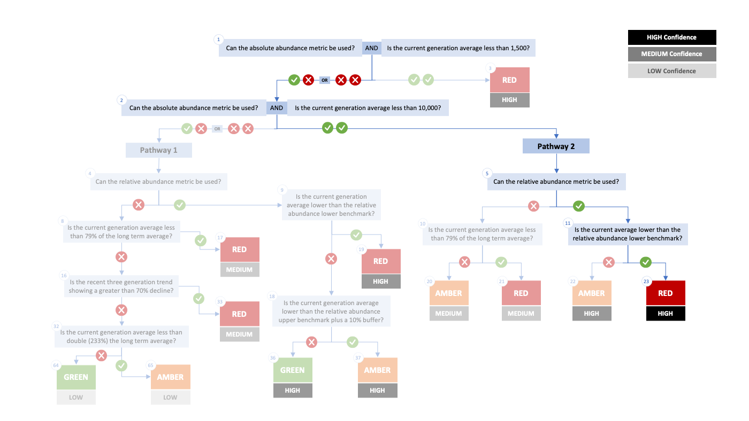Figure 6. Algorithm pathway taken to assess status for the Harrison (U/S)-L (SEL-03-04) in 2023. The recent generational average falls below the absolute abundance upper (10,000) threshold (node 1-2) and below the relative abundance upper (nodes 5 and 11). Status for this CU is therefore designated as Red with High confidence at Node 23.
Table 6: Decision tree path given data and metric values for the Harrison (U/S)-L (SEL-03-04) in 2023; this aligns with Figure 6 above. For each node, the algorithm decision is made by comparing the CUs current metric value to the metric threshold and answering Yes or No, running through sequential nodes and decisions until the final WSP rapid status for that CU and year is reached.
Node | Metric | Metric Threshold | CU’s Current Value | Decision
1 | Absolute Abundance | <1,500 | 9,378 | YES, NO
2 | Absolute Abundance | <10,000 | 9,378 | YES, YES
5 | Relative Abundance | Available? | - | YES
11 | Relative Abundance | <10,731 | 9,378 | YES
23 | FINAL STATUS NODE | - | - | RED, HIGH

SEL-04-01 Lillooet-Harrison-L
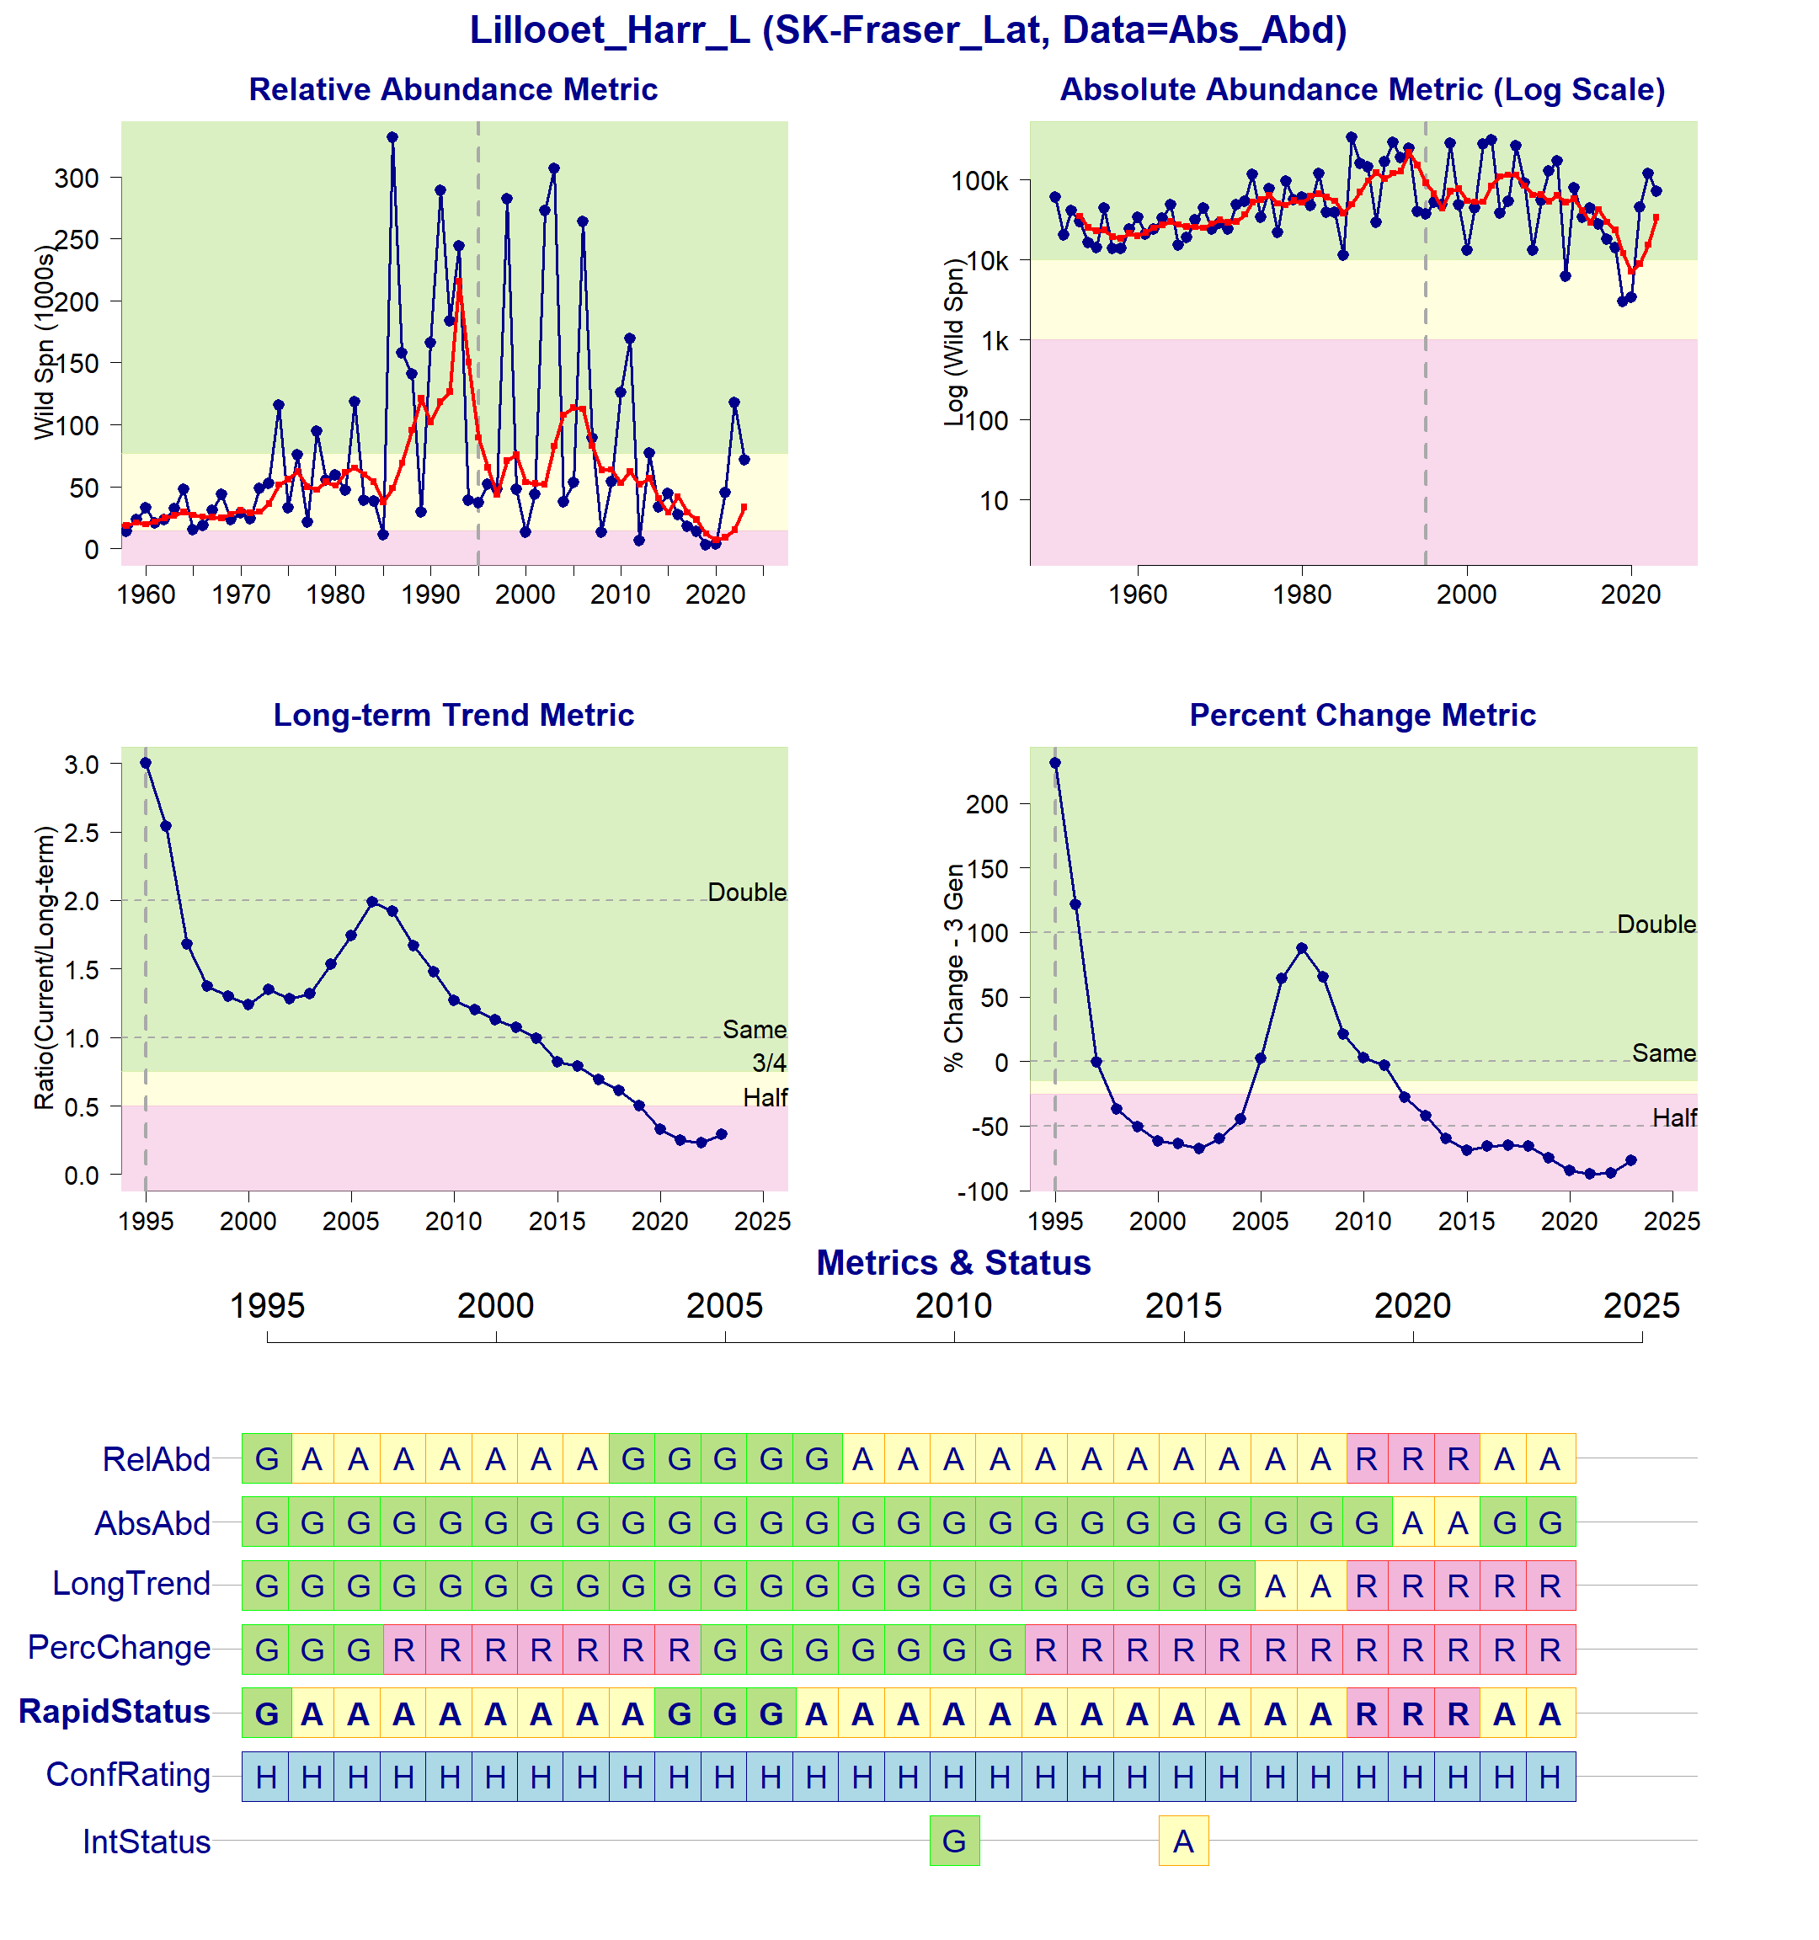Figure 7: Metrics and Status for Lillooet-Harrison-L (SEL-04-01). Panels on top show the four standard WSP metrics, calculated based on the available time series of spawner abundances. Bottom panel summarizes the status for each individual metric and shows the resulting WSP rapid status for the CU with a confidence rating. If integrated WSP status assessments have been completed for this CU, they are shown on the last row (IntStatus). Note that metric benchmarks may differ from algorithm thresholds, since thresholds approximate the status determination process from past WSP integrated status assessments (see Figure 8).
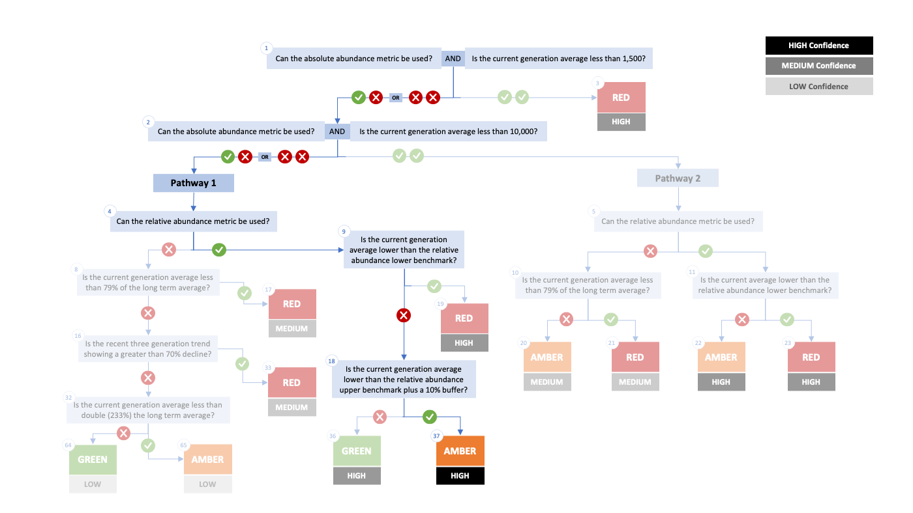Figure 8. Algorithm pathway taken to assess status for the Lillooet-Harrison-L (SEL-04-01) in 2023. The recent generational average falls above the absolute abundance upper (10,000) threshold (node 1-2) but below the relative abundance upper (nodes 4, 9, and 18). Status for this CU is therefore designated as Amber with High confidence at Node 37.
Table 7: Decision tree path given data and metric values for the Lillooet-Harrison-L (SEL-04-01) in 2022; this aligns with Figure 8 above. For each node, the algorithm decision is made by comparing the CUs current metric value to the metric threshold and answering Yes or No, running through sequential nodes and decisions until the final WSP rapid status for that CU and year is reached.
Node | Metric | Metric Threshold | CU’s Current Value | Decision
1 | Absolute Abundance | <1,500 | 33,498 | YES, NO
2 | Absolute Abundance | <10,000 | 33,498 | YES, NO
4 | Relative Abundance | Available? | - | YES
9 | Relative Abundance | <14,178 | 33,498 | NO
18 | Relative Abundance | <84,623 | 33,498 | YES
37 | FINAL STATUS NODE | - | - | AMBER, HIGH

SEL-05-11 Seton-L
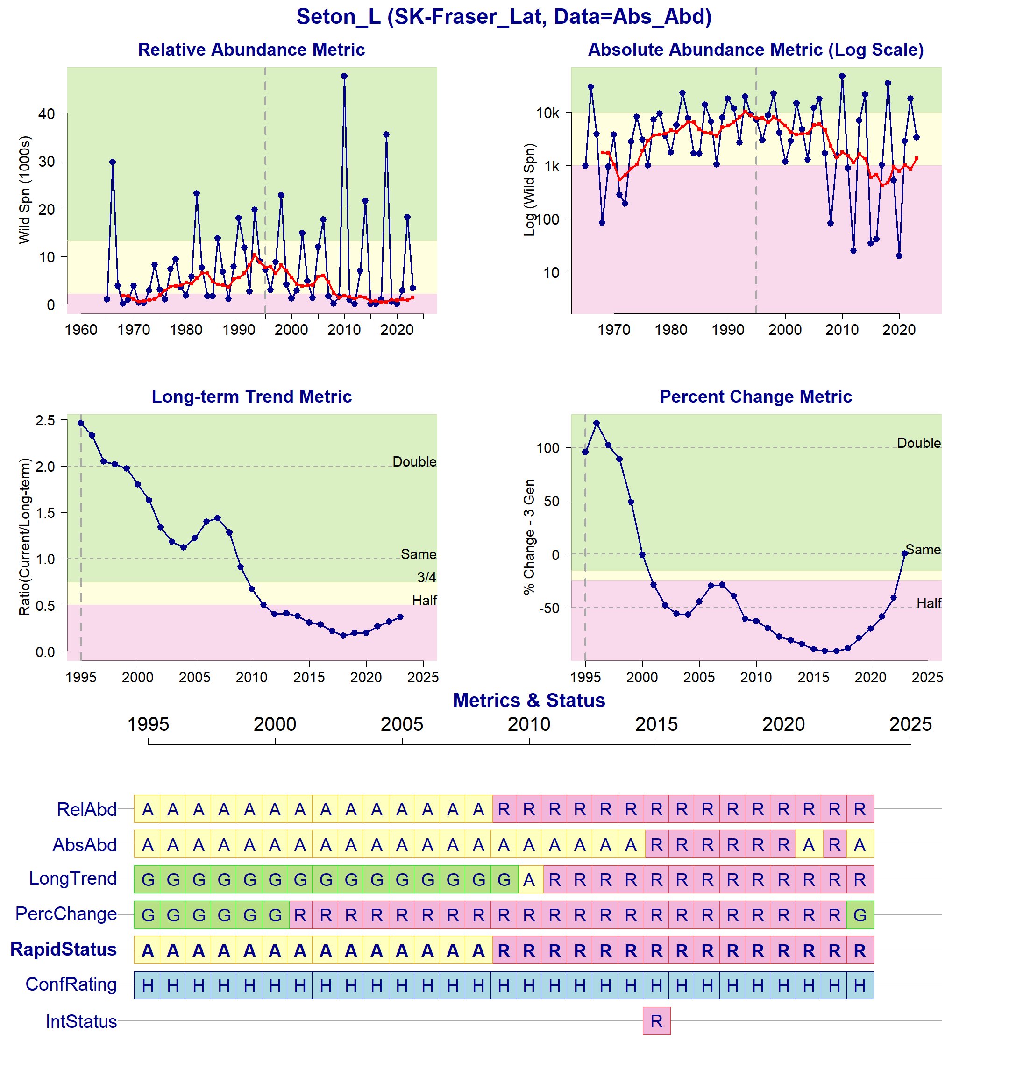Figure 9: Metrics and Status for Seton-L (SEL-05-11). Panels on top show the four standard WSP metrics, calculated based on the available time series of spawner abundances. Bottom panel summarizes the status for each individual metric and shows the resulting WSP rapid status for the CU with a confidence rating. If integrated WSP status assessments have been completed for this CU, they are shown on the last row (IntStatus). Note that metric benchmarks may differ from algorithm thresholds, since thresholds approximate the status determination process from past WSP integrated status assessments (see Figure 10).
Figure 10. Algorithm pathway taken to assess status for the Seton-L (SEL-05-11) in 2023. The recent generational average falls below the absolute abundance lower (1,500) threshold (node 1). Status for this CU is therefore designated as Red with High confidence at Node 3.
Table 8: Decision tree path given data and metric values for the Seton-L (SEL-05-11) in 2023; this aligns with Figure 10 above. For each node, the algorithm decision is made by comparing the CUs current metric value to the metric threshold and answering Yes or No, running through sequential nodes and decisions until the final WSP rapid status for that CU and year is reached.
Node | Metric | Metric Threshold | CU’s Current Value | Decision
1 | Absolute Abundance | <1,500 | 1,368 | YES, YES
3 | FINAL STATUS NODE |  |  | RED, HIGH

SEL-09-03 Shuswap-L
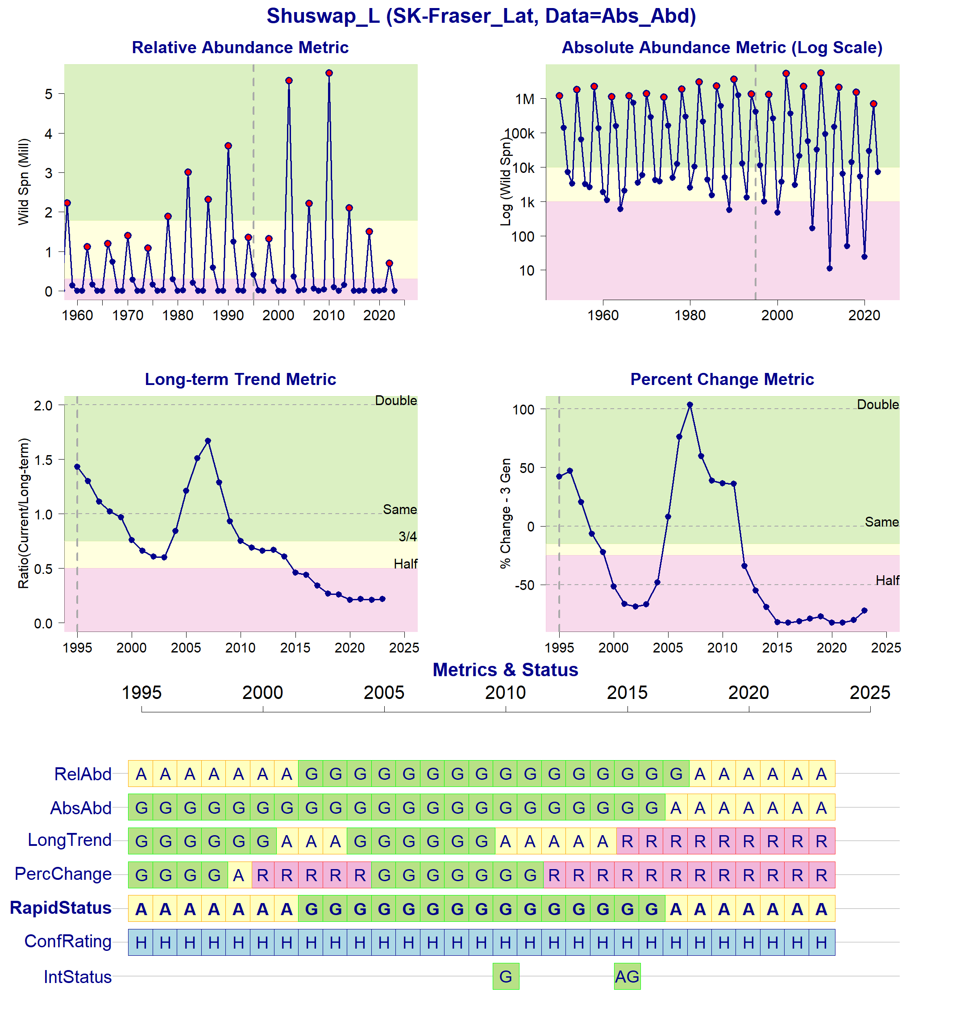Figure 11: Metrics and Status for Shuswap-L (SEL-09-03). Panels on top show the four standard WSP metrics, calculated based on the available time series of spawner abundances. Bottom panel summarizes the status for each individual metric and shows the resulting WSP rapid status for the CU with a confidence rating. If integrated WSP status assessments have been completed for this CU, they are shown on the last row (IntStatus). Note that metric benchmarks may differ from algorithm thresholds, since thresholds approximate the status determination process from past WSP integrated status assessments (see Figure 12).
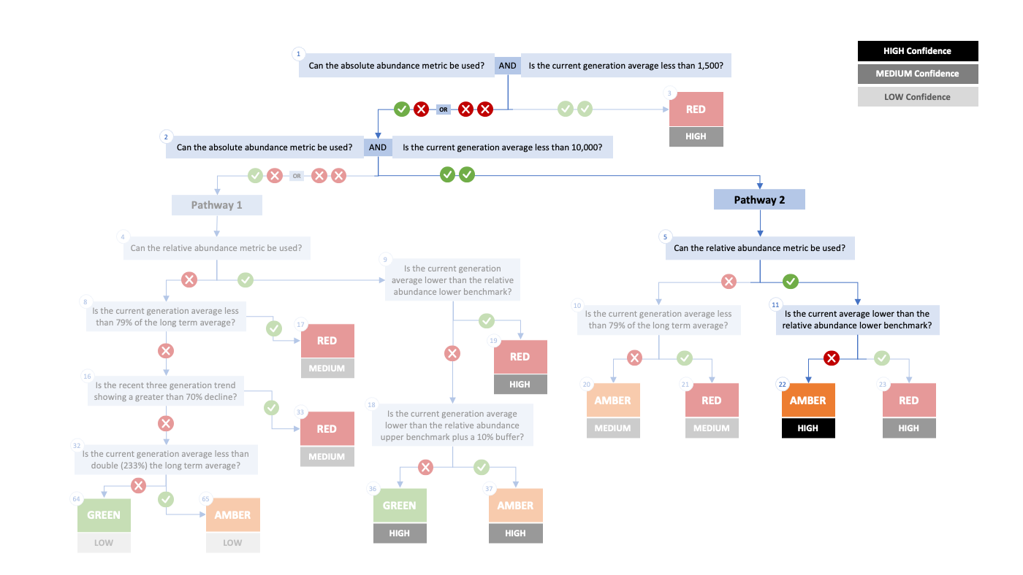Figure 12. Algorithm pathway taken to assess status for the Shuswap-L (SEL-09-03) in 2023. The recent generational average falls below the absolute abundance upper (10,000) threshold (nodes 1 and 2) and the dominant cycle abundance is above the relative abundance lower (nodes 5 and 11). Status for this CU is therefore designated as Amber with High confidence at Node 22.
Table 9: Decision tree path given data and metric values for the Shuswap-L (SEL-09-03) in 2023; this aligns with Figure 12 above. For each node, the algorithm decision is made by comparing the CUs current metric value to the metric threshold and answering Yes or No, running through sequential nodes and decisions until the final WSP rapid status for that CU and year is reached.
Node | Metric | Metric Threshold | CU’s Current Value | Decision
1 | Absolute Abundance | <1,500 | 7,739 | YES, NO
2 | Absolute Abundance | <10,000 | 7,739 | YES, YES
5 | Relative Abundance | Available? | - | YES
11 | Relative Abundance | <310,783 | 703,128 | NO
23 | FINAL STATUS NODE | - | - | AMBER, HIGH

Cited and other Key References
Doutaz, D., Huang, A.-M., Decker, S., Vivian, T. 2023. Recovery Potential Assessment for Fraser River Sockeye Salmon (Oncorhynchus nerka), Nine Designatable Units Part 2: Biology, Habitat, Threats, Mitigations and Allowable Harm - Elements 1-11, 14, 16-18, 22. DFO Can. Sci. Advis. Sec. Res. Doc. 2023/003. xiii + 250 p.
DFO. 2005. Canada’s Policy for Conservation of Wild Pacific Salmon. Fisheries and Oceans Canada, Vancouver, B.C., pp. vi+ 49.
DFO. 2009. A Fishery Decision-Making Framework Incorporating the Precautionary Approach.
DFO. 2022. Methodologies and guidelines for defining limit reference points for Pacific Salmon. CSAS SAR 2022/030. pp. 16.
DFO. 2023. Science advice on guidance for limit reference points under the Fish Stocks provisions. DFO Can. Sci. Advis. Sec. Sci. Advis. Rep. 2023/009.
DFO 2024. Rapid status approximations for Pacific salmon derived from integrated status assessments under DFO’s Wild Salmon Policy. CSAS Sci. Resp. 2024/004.
Grant, S.C.H., MacDonald, B.L., Cone, T.E., Holt, C.A., Cass, A., Porszt, E.J., Hume, J.M.B., and Pon, L.B. 2011. Evaluation of Uncertainty in Fraser Sockeye (Oncorhynchus nerka) Wild Salmon Policy Status using Abundance and Trends in Abundance Metrics. Can. Sci. Advis. Sec. Res. Doc. 2011/087. Viii + 183
Grant, S.C.H. & G. Pestal. 2013. Integrated Biological Status Assessments Under the Wild Salmon Policy Using Standardized Metrics and Expert Judgement: Fraser River Sockeye Salmon (Oncorhynchus nerka) Case Studies. Can. Sci. Advis. Sec. Res. Doc. 2012/106. v + 132 p.
Grant, S.C.H., MacDonald, B.L., and Winston, M.L. 2019. State of the Canadian Pacific salmon: responses to changing climate and habitats. Can. Tech. Rep. Fish. Aquat. Sci. 3332: ix + 50 pp. Available from http://www.dfo-mpo.gc.ca/species-especes/publications/salmon-saumon/state-etat-2019/abstract-resume/index-eng.html
Grant, S.C.H., Holt, C., Pestal, G., MacDonald, B.L. 2020. The 2017 Fraser Sockeye Salmon (Oncorhynchus nerka) Integrated Biological Status Re-Assessments Under the Wild Salmon Policy Using Standardized Metrics and Expert Judgment. Can. Sci. Advis. Sec. Res. Doc. 2020/035. vii + 211 p.
Holt, C.A., Cass, A., Holtby, B., and Riddell, B. 2009. Indicators of status and benchmarks for Conservation Units in Canada’s Wild Salmon Policy. Can. Sci. Advis. Sec. Res. Doc. 2009/058: viii + 74.
Holt, C.A., Holt, K., Wor, C., Warkentin, L., Connors, B., Grant, S.C.H., and Huang, A.-M. 2023a. Guidelines for Defining Limit Reference Points for Pacific Salmon Stock Management Units. Can. Sci. Adv. Sec. Res. Doc. 2023/009: iv + 66.
Holt, K., Holt, C.A., Warkentin, L., Wor, C., Davis, B., Arbeider, M., Bokvist, J., Crowley, S., Grant, S.C.H., Luedke, W., McHugh, D., Picco, C., and Will, P. Van. 2023b. Case Study Applications of LRP Estimation Methods to Pacific Salmon Stock Management Units. Can. Sci. Advis. Sec. Res. Doc. 2023/010: iv + 129.
Holt, C.A., and Irvine, J.R. 2013. Distinguishing benchmarks of biological status from management reference points: a case study on Pacific salmon in Canada. Environ. Conserv. 40 (4): 345–355. doi:https://doi.org/10.1017/S0376892913000209
Holtby, B.L., and Ciruna, K.A. 2007. Conservation units for Pacific salmon under the Wild Salmon Policy. Can. Sci. Advis. Sec. Res. Doc. 2007/070: viii + 350 pp. Available from http://www.dfo-mpo.gc.ca/csas-sccs/publications/resdocs-docrech/2007/2007_070-eng.htm
Huang, A-M., Pestal, G., Guthrie, I. 2021. Recovery Potential Assessment for Fraser River Sockeye Salmon (Oncorhynchus nerka) – Nine Designatable Units: Probability of Achieving Recovery Targets - Elements 12, 13, 15, 19-22. DFO Can. Sci. Advis. Sec. Res. Doc. 2021/043. x + 96.
Pestal, G., MacDonald, B.L., Grant, S.C.H., and Holt, C.A. 2023. State of the Salmon: rapid status assessment approach for Pacific salmon under Canada’s Wild Salmon Policy. Can. Tech. Rep. Fish. Aquat. Sci. 3570: xiv + 200 p.
Pestal, G., MacDonald, B.L., Grant, S.C.H., and Carr-Harris, C. 2024. State of the Salmon: Wild Salmon Policy rapid status approach for Fraser, Skeena, and Nass sockeye, Fraser pink and chum, Interior Fraser Coho, and southern BC Chinook salmon. Can. Tech. Rep. Fish. Aquat. Sci. (in Prep).

Appendix A: WSP rapid status approach details

The decision tree sequence is as follows (see Figure A1; Table A1, A2):
- The first question is whether or not a CU has a current absolute abundance value, and if so, whether or not this value falls below the lower threshold of 1,500 (which adds a buffer to Committee on the Status of Endangered Wildlife in Canada (COSEWIC) Criterion D1 for small population size of 1,000). If the answer to this question is Yes, then the CU is assigned Red (node 3), with High confidence.
- If the answer to the first question is No, then the second question is whether or not the CU has a current absolute abundance value, and if so, whether or not the current abundance is below the upper threshold of 10,000, which is COSEWIC's Criterion C upper benchmark. This second question splits the decision nodes into two Pathways: Pathway 1 (No to this question) and Pathway 2 (Yes to this question).
  - Pathway 1: is where a CU either does not have a current absolute abundance value, or has these data, and it falls above the upper threshold for this metric. This pathway is split with the question: can this CU be assessed with a relative abundance metric. If the answer is Yes, a Red (nodes 19), Amber (nodes 37) or Green (node 36) WSP rapid status is assigned, with High confidence, depending on where the current abundance value falls relative to this metric’s lower and upper thresholds. If the answer is NO, then comparisons are made between the CU’s current abundances and percent change to thresholds for these metrics, which assign a Red with Medium confidence, or Green or Amber with Low confidence status.
  - Pathway 2: is where a CU has absolute abundance data, and these abundances fall between the lower and upper thresholds. In this pathway, absolute abundances restrict WSP rapid statuses to only Amber or Red. This pathway is split with the question: can this CU be assessed with a relative abundance metric. If the answer is Yes, an Amber (node 22) with Medium confidence, or Red (node 23) with High confidence, is assigned, depending on whether the CU’s current abundance value falls above the relative abundance metric lower threshold or below. If the CU cannot be assessed with a relative abundance metric, then it is compared to the lower threshold of the Long-Term trend metric and assigned Amber (node 20) with Medium confidence if above, or Red (node 21) with Medium confidence if below.

Table A1. Biological status zones under the Wild Salmon Policy (WSP).

Status |  | Definition
 | Red | Poor status CU facing an imminent threat of extinction [revised definition, given alignment with COSEWIC Endangered statuses]
 | Amber | “While a CU in the Amber zone should be at low risk of loss, there will be a degree of lost production. Still, this situation may results when CUs share risk factors with other, more productive units”. Aligns with COSEWIC Threatened and Special Concern statuses.
 | Green | “identif[ies] whether harvest are greater than the level expected to provide on an average annual basis, the maximum annual catch for a CU, given existing conditions…there would not be a high probability of losing the CU”. Aligns with COSEWIC Not at Risk statuses.
 | DD | Data deficient. CUs have been designated as DD if there is no data available, or if the available data is insufficient for calculating status metrics (after quality control).

Table A2. WSP rapid status Learning Tree 3 status assignments by node (see Figure 1). This table presents the decisions in Learning Tree 3 that led to Red or Amber or Green status assignments; status outcomes depend on the pathway and decisions made. The final node that corresponds to the status assignment is presented below (see Figure 1).
Node | Status | Rule
Node3 | Red | Data Type is Absolute Abundance AND Absolute Abundance < 1,500
Node17 | Red | Data Type is Relative Index OR Absolute Abundance ≥ 1,500;  then Data Type is Relative Index OR Absolute Abundance ≥ 10,000;  then no Relative Abundance lower benchmark; then Long Term Trend < 79%
Node19 | Red | Data Type is Relative Index OR Absolute Abundance ≥ 1,500;  then Data Type is Relative Index OR Absolute Abundance ≥ 10,000  then have Relative Abundance lower benchmark;  then Relative Abundance < Relative Abundance lower benchmark
Node20 | Amber | Data Type is Relative Index OR Absolute Abundance ≥ 1,500;  then Data Type is Absolute Abundance AND Absolute Abundance<10,000;  then no Relative Abundance lower benchmark; then Long Term Trend ≥ 79%
Node21 | Red | Data Type is Relative Index OR Absolute Abundance ≥ 1,500;  then Data Type is Absolute Abundance AND Absolute Abundance<10,000;  then no Relative Abundance lower benchmark; then Long Term Trend < 79%
Node22 | Amber | Data Type is Relative Index OR Absolute Abundance ≥ 1,500;  then Data Type is Absolute Abundance AND Absolute Abundance<10,000;  then have Relative Abundance lower benchmark;  then Relative Abundance ≥ Relative Abundance lower benchmark
Node23 | Red | Data Type is Relative Index OR Absolute Abundance ≥ 1,500;  then Data Type is Absolute Abundance AND Absolute Abundance<10,000;  then have Relative Abundance lower benchmark;  then Relative Abundance < Relative Abundance lower benchmark
Node33 | Red | Data Type is Relative Index OR Absolute Abundance ≥ 1,500;  then Data Type is Relative Index OR Absolute Abundance ≥ 10,000;  then no Relative Abundance lower benchmark;  then Long Term Trend ≥ 79%; then Percent Change < -70
Node36 | Green | Data Type is Relative Index OR Absolute Abundance ≥ 1,500;  then Data Type is Relative Index OR Absolute Abundance ≥ 10,000  then have Relative Abundance lower benchmark;  then Relative Abundance ≥ Relative Abundance lower benchmark;  then Relative Abundance ≥ Relative Abundance upper benchmark x 1.1
Node37 | Amber | Data Type is Relative Index OR Absolute Abundance ≥ 1,500;  then Data Type is Relative Index OR Absolute Abundance ≥ 10,000  then have Relative Abundance lower benchmark;  then Relative Abundance ≥ Relative Abundance lower benchmark;  then Relative Abundance < Relative Abundance upper benchmark x 1.1
Node64 | Green | Data Type is Relative Index OR Absolute Abundance ≥ 1,500;  then Data Type is Relative Index OR Absolute Abundance ≥ 10,000;  then no Relative Abundance lower benchmark;  then Long Term Trend ≥ 79%; then Percent Change < -70  then Long Term Trend ≥ 233
Node65 | Amber | Data Type is Relative Index OR Absolute Abundance ≥ 1,500;  then Data Type is Relative Index OR Absolute Abundance ≥ 10,000;  then no Relative Abundance lower benchmark;  then Long Term Trend ≥ 79%;  then Percent Change < -70  then Long Term Trend < 233

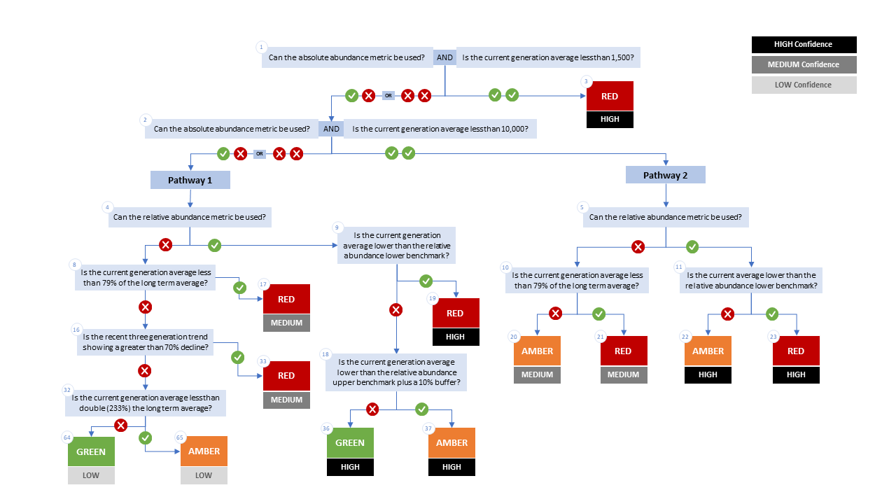

Figure A1. WSP rapid status decision tree (Table 2 includes written descriptions). To assess a CU, metric values are compared to thresholds presented at each decision point. Yes or No answers split each path of the decision tree, terminating at WSP rapid status assignments. The different splits are identified as nodes: 1 to 65. Pathway 1 is taken when the CU has no absolute abundance data, or these data exist, but fall above its upper threshold of 10,000. Pathway 2 is taken when the CU has absolute abundance data and these fall under its upper benchmark of 10,000.

Appendix B: Meeting History and Participants
Tables and summaries of meetings and participants, specifically participants who identified as a subject matter expert for one or more CUs.
Table B1. Meeting participants for the review of the 2022/23 Wild Salmon Policy Rapid Status Scanner for Fraser Pink, Chum and Sockeye. Meeting took place on January 8, 2025.
Kaitlyn Dionne | Fraser and Interior Stock Assessment, DFO
Michael Arbeider | Fraser and Interior Stock Assessment, DFO
Chuck Parken | Fraser and Interior Stock Assessment, DFO
Colin Bailey | Fraser and Interior Stock Assessment, DFO
Sue Grant | Science, DFO
Isabella Borea | Fraser and Interior Stock Assessment, DFO
Marissa Glavas | Fraser and Interior Stock Assessment, DFO
Scott Decker | Fraser and Interior Stock Assessment, DFO
Matthew Townsend | Fraser and Interior Stock Assessment, DFO
Kelsey Campbell | Upper Fraser Fisheries Commission
Pete Nicklin | Tsilqotin National Government
Elinor McGrath | Okanagan Nation Alliance
Chad Fuller | Okanagan Nation Alliance
Michelle Walsh | Secwepmec Fisheries Commission
Maxine Bruce | Lil’wat First Nation

Consensus: general agreement of group as a whole, or absence of evidence-based opposition to conclusions. Determined by the “weight of evidence” (scientific data, information, and analysis ) where multiple results are reported. In the event of disagreements, equally plausible conclusions can be reported. Dissenting views must be clearly described in the narrative.

